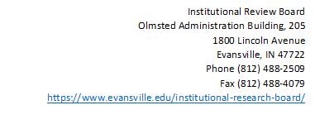
Consent Form Online Surveys
(Social, Behavioral and Educational)
Study Title: | {Insert}
Investigator(s)/Researcher(s): | {Insert name (s) & Email (s)
Department: | {Insert}
Faculty Sponsor(s): | {Insert name (s) & Email (s)

We are inviting you to participate in a research study. Your participation in this online survey is completely voluntary. If you decide to participate in the survey, you are free to withdraw at any time without any negative effect on you relations with the University or {Specified Department or Agency}. This consent form will give you information about the study to help you decide whether this is of interest to you. This study aims to investigate/understand {insert}. We are asking you to participate because... {indicate why this person is eligible}. Although the results of this study may be published, no information that could identify you will be included. {This study will pose no risk or pose limited risk to you}. {Are there incentives/payments or cost for participating?} {How will the data be stored?}
Questions regarding this study should be directed to:
Researchers: {Insert contact information}
Questions regarding your rights/complaints or problems:
University of Evansville
Academic Affairs
Dr. Tracey Folden, Institutional Review Board-Chair
812-488-2509| tf91@evansville.edu|IRB@evansville.edu
We appreciate your participation.
Sincerely,
{Name of Researcher (s)}
By clicking submit, you are consenting to participate in this survey.

